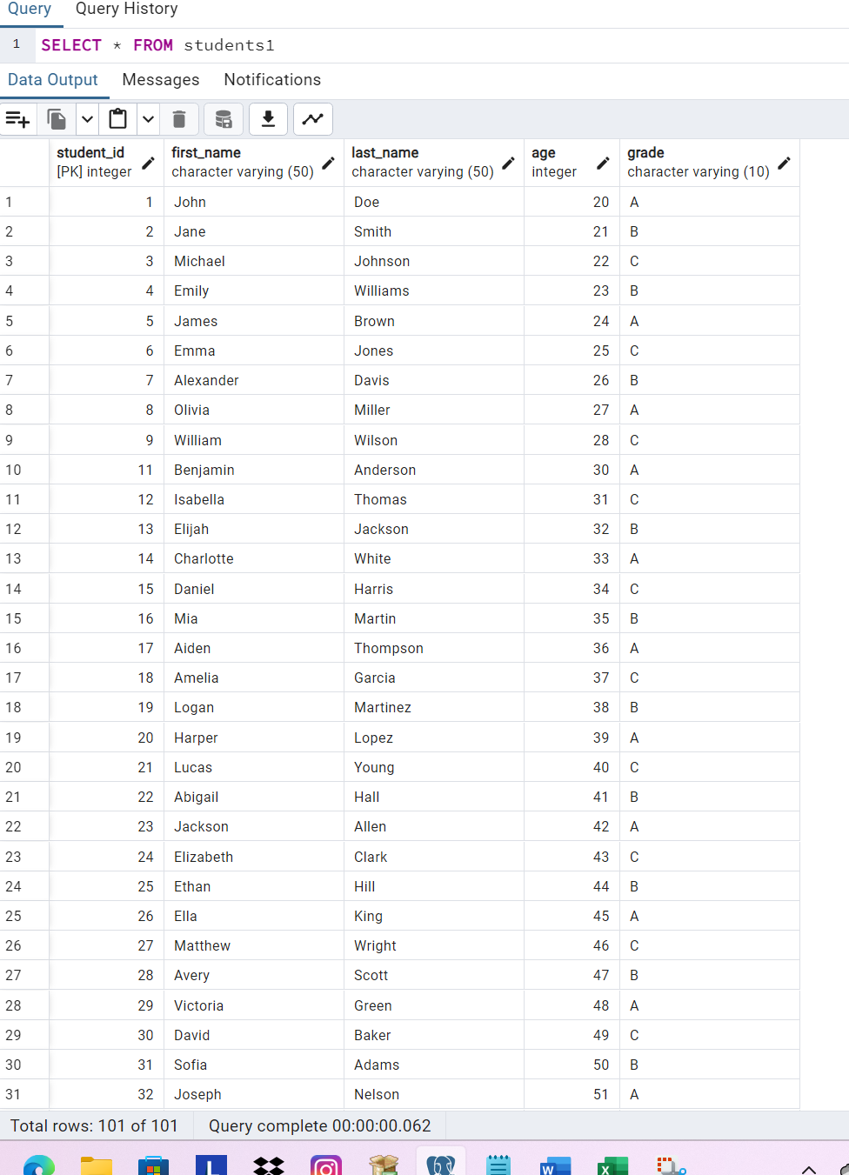

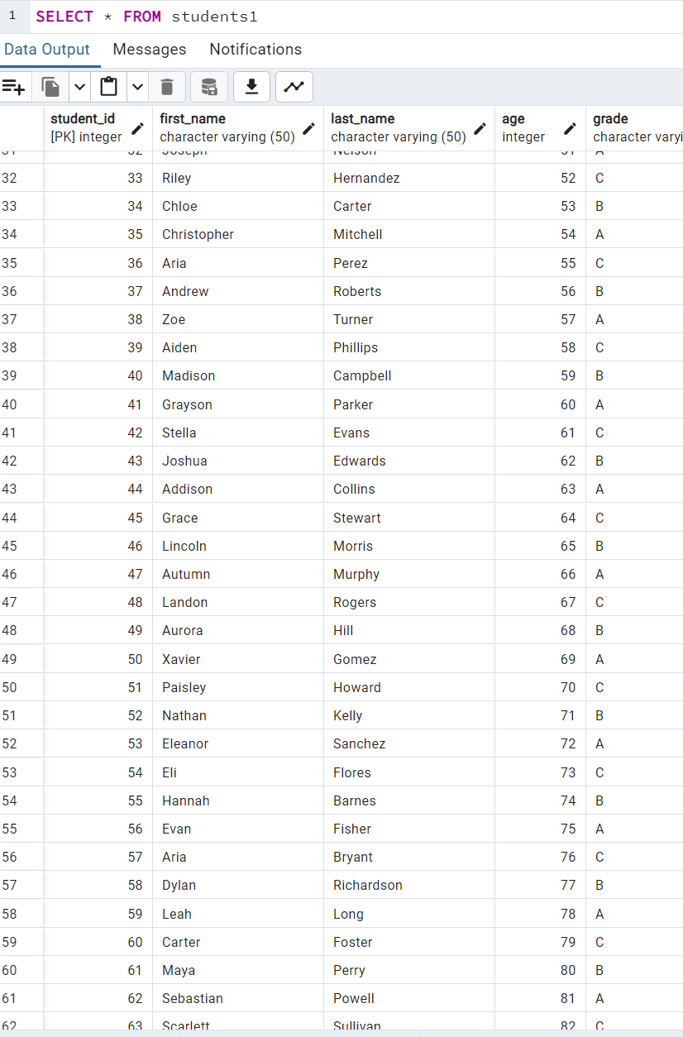



CREATE TABLE Teachers (

teacher_id SERIAL PRIMARY KEY,

first_name VARCHAR(50),

last_name VARCHAR(50),

subject_taught VARCHAR(50)

);

INSERT INTO Teachers (teacher_id, first_name, last_name, subject_taught) VALUES

(1, 'John', 'Smith', 'Mathematics'),

(2, 'Alice', 'Johnson', 'English'),

(3, 'Michael', 'Brown', 'Science'),

(4, 'Sarah', 'Williams', 'History'),

(5, 'David', 'Davis', 'Computer Science'),

(6, 'Emily', 'Miller', 'Art'),

(7, 'Daniel', 'Wilson', 'Physics'),

(8, 'Olivia', 'Taylor', 'Music'),

(9, 'James', 'Anderson', 'Geography'),

(10, 'Sophia', 'Thomas', 'Chemistry'),

(11, 'William', 'Jackson', 'Biology'),

(12, 'Emma', 'White', 'Physical Education'),

(13, 'Ethan', 'Harris', 'Foreign Language'),

(14, 'Ava', 'Martin', 'Economics'),

(15, 'Matthew', 'Thompson', 'Psychology'),

(16, 'Amelia', 'Garcia', 'Sociology'),

(17, 'Liam', 'Martinez', 'Political Science'),

(18, 'Charlotte', 'Lopez', 'Philosophy'),

(19, 'Benjamin', 'Young', 'Anthropology'),

(20, 'Harper', 'Hall', 'Literature');

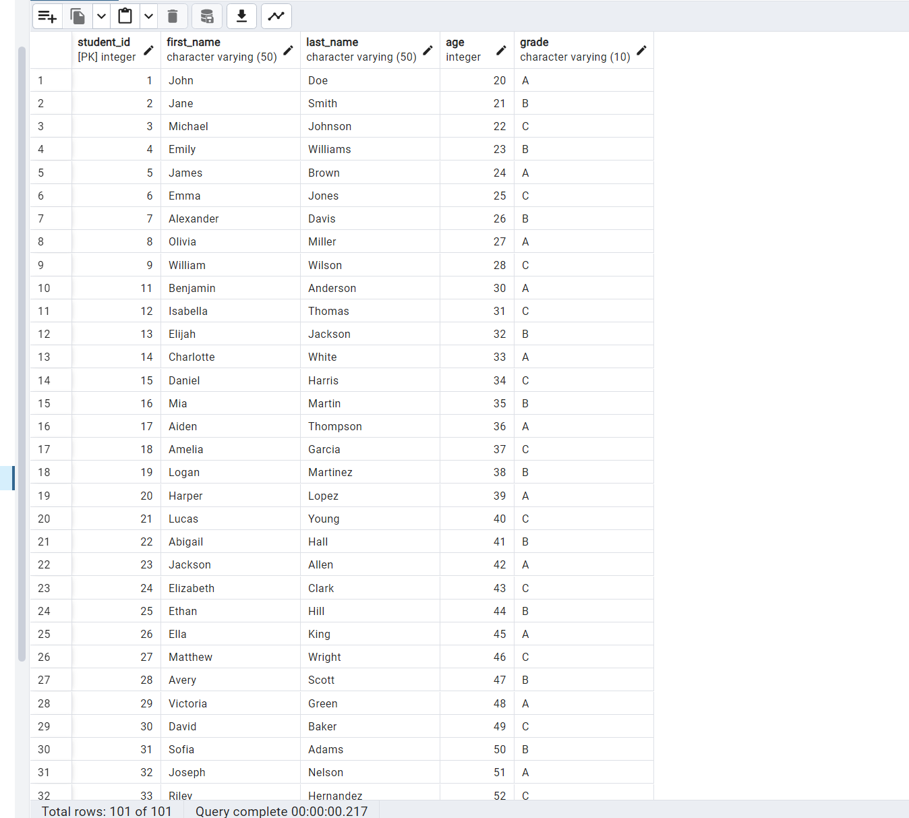

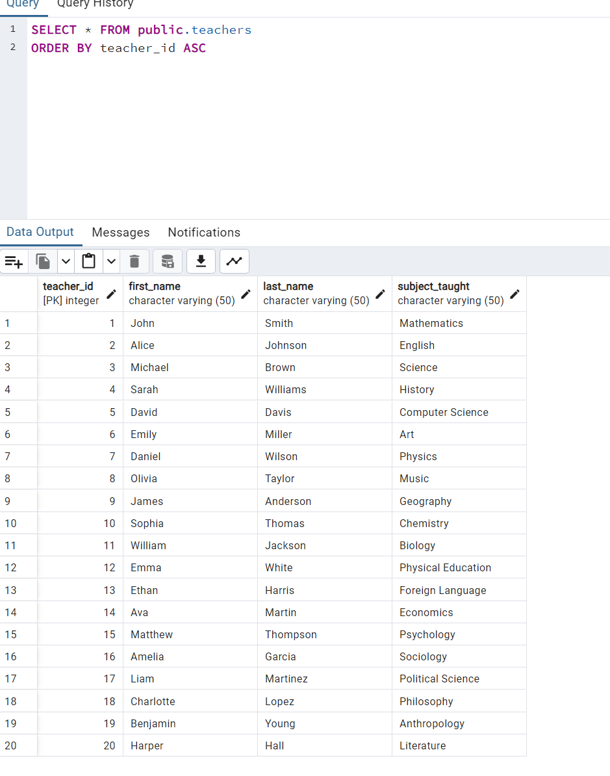

**CREATE TABLE Courses (**

**course_id SERIAL PRIMARY KEY,**

**teacher_id INT,**

**course_name VARCHAR(100),**

**FOREIGN KEY (teacher_id) REFERENCES Teachers(teacher_id)**

**);**

**INSERT INTO Courses (course_id, teacher_id, course_name) VALUES**

**(1, 1, 'Introduction to Computer Science'),**

**(2, 2, 'Data Structures and Algorithms'),**

**(3, 3, 'Database Management Systems'),**

**(4, 4, 'Web Development Fundamentals'),**

**(5, 5, 'Software Engineering Principles'),**

**(6, 6, 'Machine Learning Basics'),**

**(7, 7, 'Network Security Fundamentals'),**

**(8, 8, 'Operating Systems Concepts'),**

**(9, 9, 'Artificial Intelligence Fundamentals'),**

**(10, 10, 'Mobile Application Development');**

